Vision and Scope Document

for

Mini Aparartment Management

Version 1.0 approved

Prepared by Group 6

Le Tuan Cuong

Nguyen Binh An

Nguyen Tan Viet

Ngo Tran Minh Hoa

Nguyen Anh Duc

February 6,2025

Table of Contents

Table of Contents ii

Revision History ii

1. Business Requirements 1

1.1. Background 1

1.2. Business Opportunity 1

1.3. Business Objectives 1

1.4. Success Metrics 1

1.5. Vision Statement 1

1.6. Business Risks 1

1.7. Business Assumptions and Dependencies 2

2. Scope and Limitations 2

2.1. Major Features 2

2.2. Scope of Initial Release 2

2.3. Scope of Subsequent Releases 2

2.4. Limitations and Exclusions 2

3. Business Context 2

3.1. Stakeholder Profiles 2

3.2. Project Priorities 3

3.3. Deployment Considerations 4

Revision History

|  |  |  |  |
| --- | --- | --- | --- |
| **Name** | **Date** | **Reason For Changes** | **Version** |
| Le Tuan Cuong | 3/2/25 | initial draft | 1.0 draft 1 |
| Le Tuan Cuong | 4/2/25 | Add progress | 1.0 draft 2 |
| Le Tuan Cuong | 6/2/25 | baseline following changes after inspection | 1.0 appoved |

# Business Requirements

## Background

## The gaming market has expanded globally, with millions of users engaging in online shopping for video games, accessories, and related merchandise. Despite the availability of online stores, there are gaps in providing an intuitive, seamless, and personalized experience for gamers. This project aims to develop a robust and user-friendly platform that allows customers to shop for games, merchandise, and accessories from a variety of platforms, all in one place.

## Business Opportunity

## The current online game shopping experience can often feel fragmented, with multiple platforms needed to cover a wide range of games and accessories. This project offers an opportunity to consolidate these offerings into one streamlined platform, offering a range of digital and physical game products, exclusive content, and tailored promotions. By offering both a web and mobile experience, the platform can target a wide audience of gamers seeking convenience, better deals, and community integration.

## Business Objectives

* **BO-1**: Achieve a 15% market share of online game sales within the first year of operation.
  + **Scale**: Total online game sales
  + **Meter**: Monthly sales data
  + **Past**: New product
  + **Goal**: 15% market share by the end of year 1
  + **Stretch**: 20% market share
* **BO-2**: Increase customer retention rate to 40% by the end of year 1.
  + **Scale**: Percentage of return customers
  + **Meter**: User account data and transaction history
* **BO-3**: Reduce the average order processing time by 25% in the first 6 months after launch.
  + **Scale**: Order processing time
  + **Meter**: Time to process and ship orders

## Success Metrics

• **SM-1**: 80% of users who visit the site purchase at least one game within 3 months.

• **SM-2**: Achieve a customer satisfaction rating of at least 4.5 out of 5 from surveys.

• **SM-3**: Reach 100,000 active users within the first 6 months post-launch.

## Vision Statement

## The Game Shopping Web is an all-in-one online platform that allows gamers to browse, purchase, and review a wide range of games, merchandise, and accessories across multiple platforms. It is designed to offer a seamless experience whether users are on desktop or mobile, with fast, secure transactions, personalized recommendations, and an interactive community for sharing gaming experiences.

## Business Risks

## *RI-1: Low initial user adoption, which could impact platform success and revenue generation.*

## *Probability: 0.4*

## *Impact: 8*

## *RI-2: Supplier and game distributor delays may affect product availability, leading to customer dissatisfaction.*

## *Probability: 0.3*

## *Impact: 6*

## *RI-3: Technological challenges in integrating payment gateways and user accounts across platforms.*

## *Probability: 0.5*

## *Impact: 7*

## Business Assumptions and Dependencies

* **AS-1**: Partnerships with major game developers and distributors are in place for inventory supply.
* **AS-2**: The system will be compatible with both Android and iOS devices for mobile access.
* **DE-1**: Payment gateway systems (e.g., PayPal, Stripe) will be integrated without major delays.

# Scope and Limitations

## Major Features

**•** FE-1: Browse and purchase games, accessories, and merchandise

* Search games by category
  + Genre
  + Platform (PC, PlayStation, Xbox, etc.)
* Browse accessories
  + Controllers
  + Headsets
  + Merchandise (T-shirts, Posters, etc.)
* View discounts and bundles
  + Promotions
  + Game bundles

• FE-2: Create, view, modify, and manage user accounts

* Register a new account
  + Create new account using email or social login
* Login
  + Secure login with password
* View order history
  + Previous purchases
* Manage profile
  + Edit profile information (name, email, etc.)
* Manage wishlists
  + Add or remove games/accessories to/from wishlist
* Manage preferences
  + Update notification preferences, themes, etc.

• FE-3: Order and pay for products

* Add products to shopping cart
  + Game selection
  + Accessories and merchandise
* Apply promo codes
  + Discounts or special offers
* Proceed to checkout
  + Shipping address
  + Payment options
* Track order status
  + Real-time shipping updates

• FE-4: User reviews and ratings

* Rate games and accessories
  + Leave a rating (1-5 stars)
  + Write a detailed review
* View user reviews
  + See average ratings for products
  + Read customer feedback

• FE-5: Personalized product recommendations

* Suggestions based on purchase history
  + Recommended games and accessories
* Suggestions based on browsing activity
  + Games users have viewed or added to the cart
* Trending products
  + Popular games and products

• FE-6: Mobile and web access

* Web access via browsers
  + Fully responsive design
* Mobile access via iOS and Android apps
  + Seamless mobile shopping experience
* Push notifications
  + Game releases, deals, and recommendations

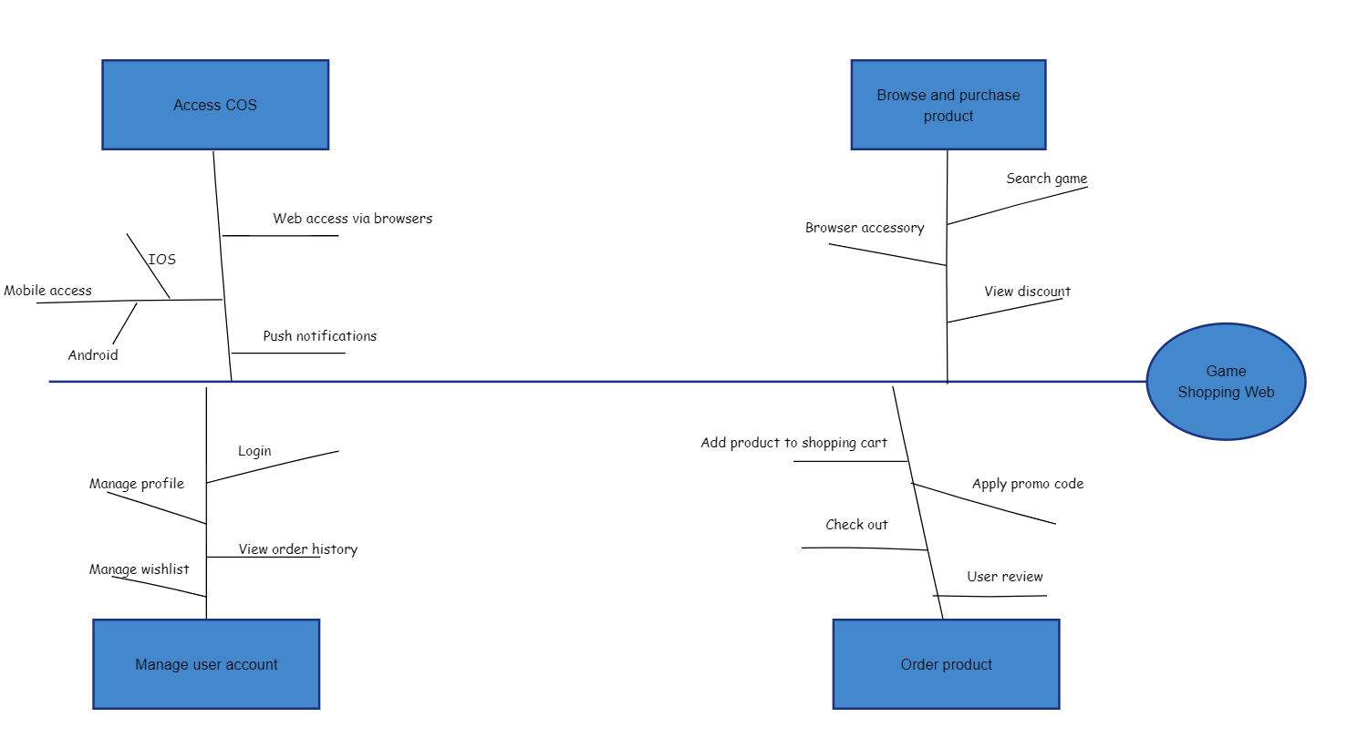

## Scope of Initial & Subsequent Release

|  |  |  |  |
| --- | --- | --- | --- |
| Feature | Release 1 | Release 2 | Release 3 |
| Product catalog | Basic game catalog | Expand to include accessories and bundles | Fully comprehensive catalog with detailed reviews |
| Search and filter | Basic filters (genre, platform) | Advanced filters (price range, ratings) | Full advanced filtering and sorting options |
| User accounts | Create, view, and manage accounts | Add social media logins | Integrate gamification and loyalty programs |
| Secure checkout | Credit card and PayPal payments | Implement regional payment systems | Add installment payment options |
| User reviews and ratings | Basic review system | Enable video reviews | Expand to include user-generated content and guides |
| |  | | --- | | Mobile support | | Fully responsive mobile website | Dedicated mobile apps (iOS & Android) | Full mobile integration with exclusive mobile-only deals |

## Limitations and Exclusions

* **LI-1**: The platform will not support physical store purchases in the first release.
* **LI-2**: Shipping integration with local retailers will not be available initially.
* **LI-3**: Game streaming services will not be offered in the initial release.

# Business Context

## Stakeholder Profiles

|  |  |  |  |
| --- | --- | --- | --- |
| **Stakeholder** | **Major Value** | **Major Interests** | **Constraints** |
| Gamers | Convenience, game variety, personalized experience | Easy navigation, wide selection, good prices | Needs mobile access, regional availability for games |
| Game Developers | Increased visibility, higher sales | Exposure to new markets, quick payments | Concern over platform policies, development time |
| |  |  | | --- | --- | | |  | | --- | |  |   **Administrators** | | Operational efficiency, easy product management | Simple dashboard for inventory and orders | Platform stability, minimal downtime |
| Investors | Return on investment, growth potential | Fast growth, user acquisition, and retention | Budget and resource constraints |

## Project Priorities

|  |  |  |  |
| --- | --- | --- | --- |
| **Dimension** | **Driver (state objective)** | **Constraint (state limits)** | **Degree of Freedom (state allowable range)** |
| Features | Launch with 80% of key features fully implemented | Initial release should have only core features | Future updates for more features |
| Quality | Achieve 95% accuracy in transactions and reviews | Must pass security and performance tests | Incremental updates post-launch |
| Schedule | Release MVP by Q4 2025 | 2-week flexibility post-release | May need extra time for testing |
| Cost | Keep development cost within 1.000.000VND | Budget overruns must be approved by stakeholders | Cost flexibility for critical features |

## Deployment Considerations

• **Infrastructure**: Cloud-based infrastructure to support scalability and high availability, especially during high-demand periods like game launches.

• **User Access**: Ensure mobile and desktop users have a seamless experience, regardless of location.

• **Training**: Minimal training required as the platform will be designed to be intuitive, but customer support channels will be set up for any issues.